### **Write the python program to implement Apha & Beta pruning algorithm for gaming**

### **AIM**

To implement **Alpha-Beta Pruning Algorithm** in Python to optimize the Minimax search by pruning branches of the game tree that do not affect the final decision.

### **Algorithm**

1. Start with root node, initialize alpha = -∞, beta = +∞.
2. If the node is a **leaf node**, return its value.
3. If it’s a **Maximizing Player**:
   1. Initialize best = -∞.
   2. For each child:
      1. Call recursively with minimizing player.
      2. Update best = max(best, val).
      3. Update alpha = max(alpha, best).
      4. If beta <= alpha, prune remaining branches.
4. If it’s a **Minimizing Player**:
   1. Initialize best = +∞.
   2. For each child:
      1. Call recursively with maximizing player.
      2. Update best = min(best, val).
      3. Update beta = min(beta, best).
      4. If beta <= alpha, prune remaining branches.
5. Return the best value.

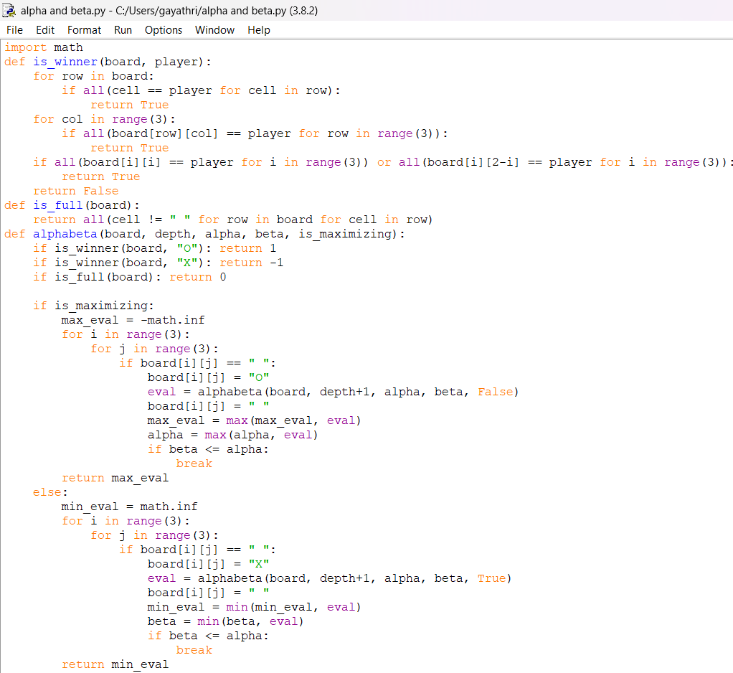

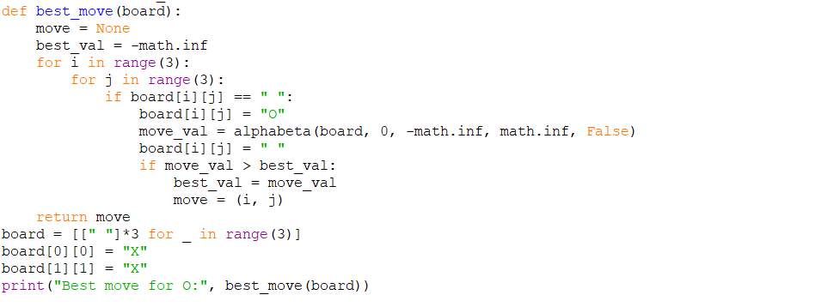

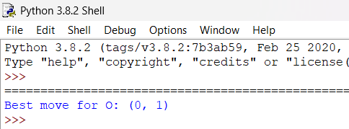

### **Result / Output**

For leaf nodes: [3, 5, 6, 9, 1, 2, 0, -1]